**Introduction to the 1000-Class feature detector**

The ''image_classification.exe'' is to detect a 1000-D feature vector in which each element value represents the score that the image belongs to a concept class. The list of 1000 classes from the Imagenet ( <http://www.image-net.org/> ) is listed in the file ''1000d.xlsx''. The ImageNet dataset annotated 1000 image concepts collected from the WordNet human knowledge database, and there are about 1000 to 1300 images annotated for each concept.

We have integrated four main modules including **feature configuration**, **feature extraction**, **SVM learning** into the image_classification.exe file.

* The feature configuration module configures different image features, including HOG (SIFT), LBP, color (histogram or color moment) features, from a unified script format.
* Then the feature extraction module extract image features using the configuration for both the training and test stage.
* The SVM model learning module can optimize linear classification models from a set of image features and labels.

We provide a demo example in the directory to make users understand how to use the program.

1. The operating system should be windows 7, 64bit.
2. First, the user should create an image list file. In the list file, the paths of to-be-detected images are provided. We provide some demo testing images in the directory ''Demo_test'', and there is a demo of the image list file in "demolist.txt".
3. The user should run the program "image_classification.exe" in the command window, and the input parameter of program is the path of image list file. Here we take our demo testing image for example. The command is shown in Figure 1:

C:\Users\qsh\AppData\Local\Temp\mx31A65.png

Figure 1. The example of the command to run the image.

1. The display of running program is shown in Figure2:

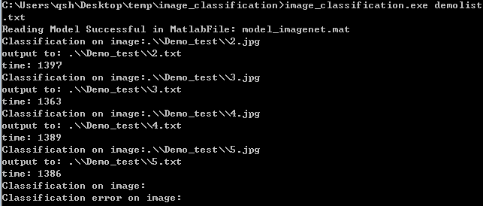

Figure 2. The display of the example running.

The output of the program is the decision scores for 1000 classes. The users can convert the decision scores into classification results in some designed ways. For example, you may want to select the top 5 or 10 classes with high scores (also larger than 0) as the positive classes, which can lead to a better accuracy. The output files are in the same directory with the testing image, and the output file name is the same to the testing image while with different file extensions.

In our demo example, the detection result files are stored in the directory "Demo_test", the result file of "2.jpg" is "2.txt". The content of file "2.txt" is 1000 decision scores corresponding to the 1000 classes in "1000d.xlsx".

In summary, we can’t make sure that this feature vector will be better than others. You should try more.